To create a POD follow below steps in declarative way (using YAML)
kubernetes-fundamentals/07-PODs-with-YAML at master · stacksimplify/kubernetes-fundamentals
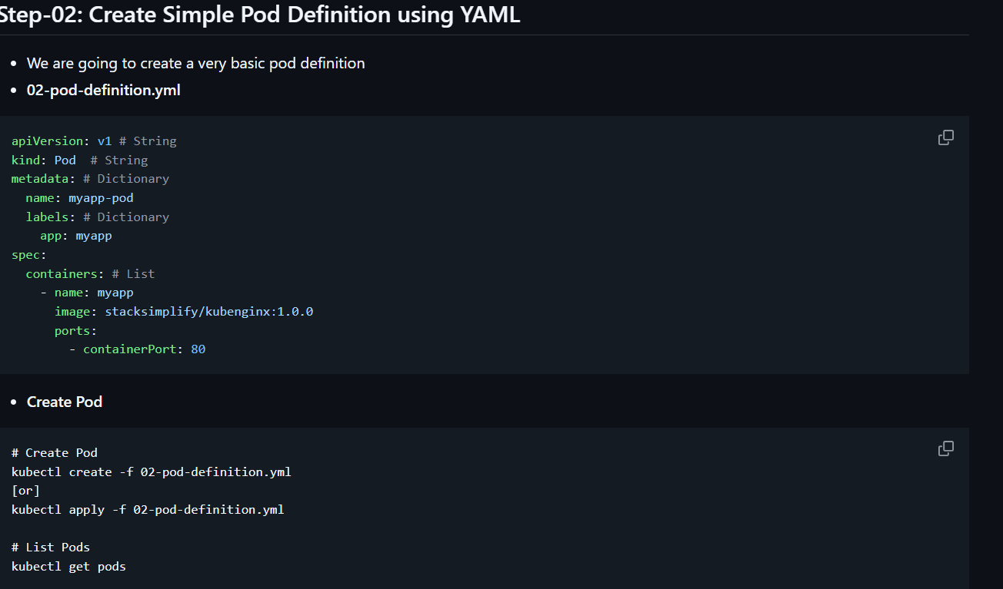
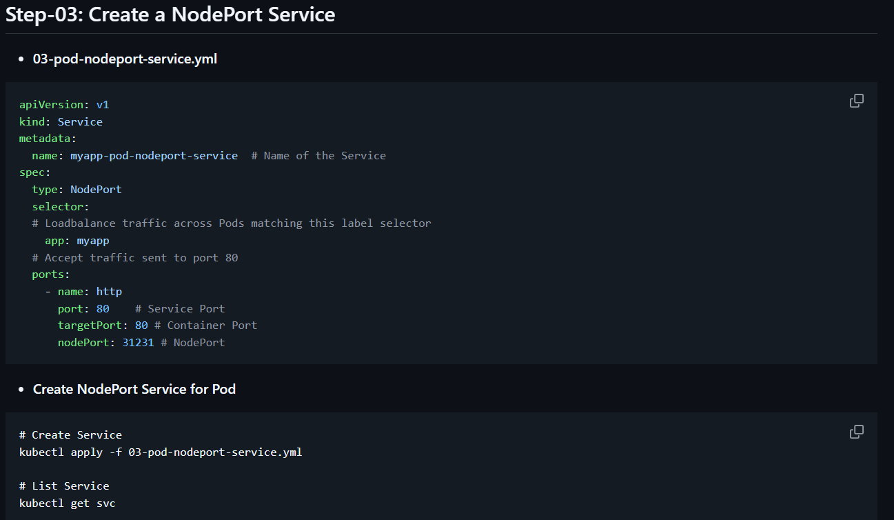
For POD API version refer Pod | Kubernetes
For Service API version refer Service | Kubernetes
For all K8s API references Kubernetes API | Kubernetes .

ReplicaSet:
To create ReplicaSet follow this kubernetes-fundamentals/08-ReplicaSets-with-YAML at master · stacksimplify/kubernetes-fundamentals .
Deployment:
To create Deployment follow this kubernetes-fundamentals/09-Deployments-with-YAML at master · stacksimplify/kubernetes-fundamentals .

